How to do SNMP WALK With the GUI Tool

Please follow below instructions to check whether the SNMP of target devices (Please choose 1-2 problematic devices as target devices) are working properly.

1. Open the NetBrain SNMPWalkTool.exe (Please download it from: <https://ws2.netbraintech.com/download/SNMPWalkTool.zip>) on your NetBrain Front Server, set Target IP address (One device at a time), SNMP credentials to retrieve the SNMP data. Please note that this could take some time. After the process is finished, the program will create a text file of the walk result. Please change the timeout to 60 seconds in the SNMPWalk Options.

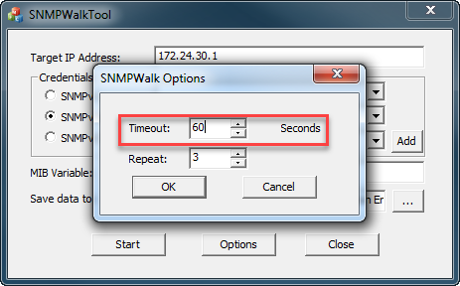

1. Please enter the SNMP string and MIB variable: 1.3.6.1, and start the walk process. (It may take several minutes to retrieve the results).

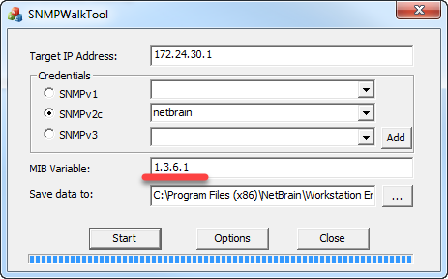

1. Please check the result, if the result is empty, that means the server cannot get SNMP information from the devices.
2. If the result is not empty, please send the saved data as a txt file to us for further analyze.